**Physics – Animations and Interactive Diagram Ideas**

# Fundamentals

## Motion - Projectile Motion

The basic idea is to have an object such as a cannon ball be shot up into the air and reach a specific maximum height, and fall back to the ground at distance d (change the range R to distance d).

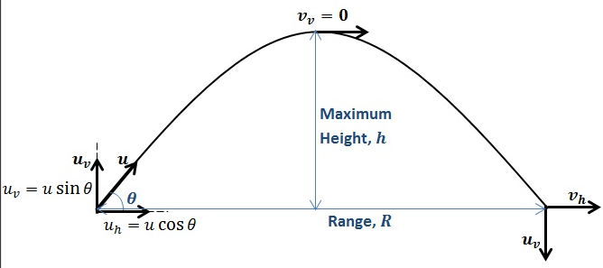

**Here is how the above diagram would work:**

* Start the projectile (cannon ball) at the bottom left corner (ask the user for information such as: angle (Ɵ), and initial velocity (vi))
* Once the user executes the animation, the object (cannon ball) will move according to user input
* When the ball reaches the top, pause for 3-5 seconds:

Have a notification pop up that says when height (h) is at maximum, y-velocity (vy) is zero. The ball will now begin to fall and the only thing affecting the y-velocity is gravity (in the downwards direction towards Earth)

*‘Calculate height at each individual point to demonstrate the projectile motion*

*‘Initial time will be 0, and therefore height will be 0*

*‘Time must increment by any small number* ***n (eg. 0.001)*** *for the equation*

*‘The height change will be shown on screen depending on time (t)*

*‘Use equation d=viy(t) + ½(a)(t2) to calcualte the height based on the changing time*

*‘In the equation d is the height (vertical distance) viy is the vertical velocity calculated by vi*sin(Ɵ), both of which are given by the user (both vi and Ɵ), a is the acceleration which is -9.81*

*‘For a clear understanding of the equation, refer to the equation*

*‘Stop calculating (stop the loop) when the height is 0 (this means that the projectile has landed on the ground)*

## Energy - Spring Diagram

The basic idea here is to show how potential energy changes as a spring is stretched.

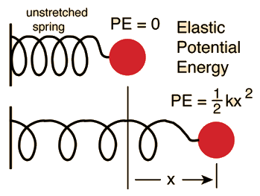

**Here is how the above diagram would work:**

* Have the spring start at an initial state where the potential energy is equal to 0 (in other words have the spring start off unstretched)
* Have a heading at the top of the spring called “Potential Energy” (its initial value is 0)
* Allow the user to input a value called (Spring Force Contact ‘k’ in newton/meter)
* Allow the user to click-and-hold a certain part of the spring
* Allow the user to stretch this part of the spring to the right
* Display the increasing potential energy value using the formula in the diagram above, where x is the distance stretched

Note: The spring constant k -> measures how stiff and strong the spring is

*‘Retrieve input from user for the k value (Spring Constant in newton/meter)*

*‘Calculate x (the distance the spring is stretched in meters) based on how far the user stretches the spring*

*‘Plug the values into the formula and show the increasing potential energy as a value on top of the diagram*

*‘For large values of k, the diagram should be animated in such a way to show that the spring requires a larger force in order to stretch (for example: stretching the spring can be animated slower for a large value of k when compared to the animation for a smaller value of k)*

## Elastic and Inelastic Collisions - Elastic Collisions

The basic idea of this diagram is to show how elastic collisions work and how the conservation of linear momentum comes into effect.

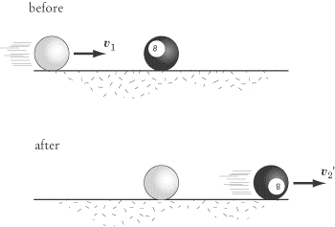

**Here is how the above diagram would work:**

* Have two balls drawn, with one starting on the left hand side (Ball A) and one in the middle (Ball B)
* Have a heading at the top of the diagram showing the changing velocities of each ball
* The user should be able to enter the initial velocity at which Ball A moves towards the Ball B
* The user should also be able enter a mass for the balls (assume that both balls have the same mass)
* The user should then be able to click a button that starts the animation
* Then Ball A should strike Ball B at a certain velocity, sending Ball B at another velocity
* Ball A should come to a stop and Ball B should move at ball A’s initial velocity
* Here is the formula for conservation of energy:



# Electricity and Magnetism

## Magnetic Force on a Moving Charge

How the magnitude of the magnetic force affects the velocity of a travelling electron through the magnetic field.

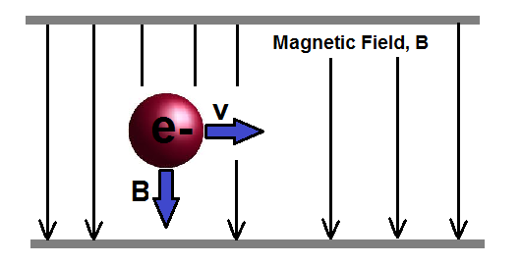

**Here is how the above diagram would work:**

* Start the projectile (electron) at the left of the screen
* The object (the electron) will move to the right and the velocity of the ball will be related to user input on the magnitude of the magnetic field B
* Animation repeats itself when the electron gets to the right end of the diagram

Equation: F = qvB sinθ (assume θ=90)

v = F/qB thus there is an inverse relationship between B and v (higher the magnetic field force the slower the v)

## Methods of Inducing Electric Charge

1. Charging by Friction



1. Charging by Contact (conduction)



1. Charging by Induction

🡪 replace wall with same type of rod used in two previous examples